Pulsar Software Requirements Specification V0.1

|  |
| --- |
|  |
|  |
|  |

|  |  |  |  |
| --- | --- | --- | --- |
| Date: | 2023-01-11 | | |
| Submitted to: | For MPBC Internal Use Only | Submitted by: | MPB Communications Inc.  147 Hymus Boulevard  Pointe-Claire QC, H9R 1E9  Tel: 514-694-8751 |
| MPB Communications Inc. and Subcontractors Proprietary Information  RESTRICTION ON USE, PUBLICATION OR DISCLOSURE OF PROPRIETARY INFORMATION  This document contains information proprietary to MPBC, or to a third party to which MPBC may have legal obligation to protect such information from unauthorized disclosure, use or duplication. Any disclosure, use or duplication of this document or any of the information contained herein for other than the specific purpose for which it was disclosed is expressly prohibited except as MPBC may otherwise determine. | | | |



Pulsar

MPB Space Dxxxxx

MPB Communications Inc.

Table of Contents

1. Introduction 5

1.1. Purpose 5

1.2. Applicable documents 5

1.3. Revision Log 5

1.4. Definitions 6

2. Description of the Deliverable Product 7

2.1. General Description of the Deliverable Product 7

2.2. Architecture of the Deliverable Product 7

2.2.1. Functional 7

3. Software Requirements 19

3.1. Memory Management Requirements 19

3.2. HPA Single Mode Laser Diode Controller 19

3.2.1. Single-mode LD Monitor 19

3.2.2. Single-mode LD Alarms 20

3.2.3. Single-mode LD Control 20

3.3. HPA Multi-Mode Laser Diode Controller 21

3.3.1. Multi-mode LD Monitor 21

3.3.2. Multi-mode LD Alarms 21

3.3.3. Multi-mode LD Control 22

3.4. Normal Behaviour Expectations 23

Table of Figures

Figure 1 HPA output power ADC channels 8

Figure 2 LOS detection 9

Figure 3 LOS detection logic 9

Table of Tables

Table 1 HPA transition table 12

# Introduction

## Purpose

This document specifies the requirements for the SOFTWARE requirements for the Pulsar.

The requirements for the Ground Station Support Equipment (GSE) are NOT included in this document.

## Applicable documents

The latest versions of the following documents are relevant to this document:

|  |  |
| --- | --- |
| Mynaric File | Short Title |
| 503RS32388.2.00_CONDOR_Mk3_EDFA_Requirements v4.xlsx |  |
|  |  |
|  |  |

|  |  |
| --- | --- |
| MPB File | Short Title |
|  |  |
|  |  |
|  |  |

## Revision Log

|  |  |  |  |
| --- | --- | --- | --- |
| Date | Version | Modified by | Modifications |
| 2024-01-17 | v0 - draft | Juan Andres Castano | First distributed version |

## Definitions

| Acronym | Description |
| --- | --- |
|  |  |
|  |  |
|  |  |
|  |  |

# Description of the Deliverable Product

## General Description of the Deliverable Product

The main deliverable item is an Optical Amplifier (OA).

The secondary deliverable(s) is the support equipment (Software and hardware) to allow the OA to be verified before its integration into other projects. This is to be specified in a separate document.

## Architecture of the Deliverable Product

### Architecture

2.2.1.1 The unit shall contain a booster section for transmission, a LNA section for receiving and a common control section for internal control and external communication. (CM3-REQ-EDFA-201-1N)

2.2.1.2 The unit shall contain a booster section to optically amplify two input channels. (CM3-REQ-EDFA-202-1N)

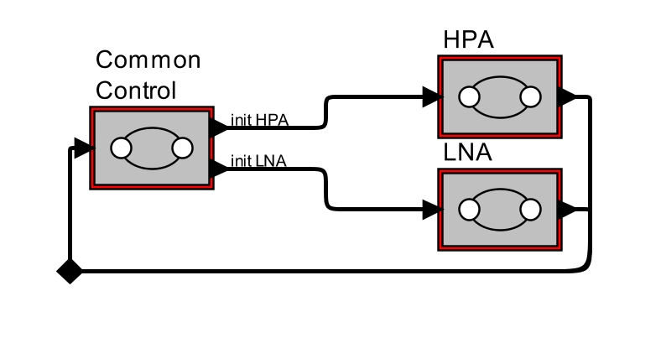

Figure 1 HPA output power ADC channels

### General Functional

#### Sections

2.2.1.6.1 The unit shall have a control mode (ACC automatic current control), where each pump laser in the booster section or LNA section can be controlled individually.( CM3-REQ-EDFA-208-1)

2.2.1.6.2 The unit shall have a control mode (APC automatic power control), where the pump lasers are controlled internally as to maintain a stable preset optical output level over the entire booster and LNA optical output range.( CM3-REQ-EDFA-209-2).

|  |  |  |  |  |
| --- | --- | --- | --- | --- |
| STATE | State action | Transitions | | |
| **Direction** | **Type** | **Conditions** |
| ON | Optical Amplifier powered up. | From : “OFF” | External | Electrical power supplied to OA. |
| To : “STARTUP” | Automatic | All internal OA electronics successfully powered up. |
| STARTUP | Execute **StartupProtocol** | From: “ON” | Automatic | All internal OA electronics successfully powered up. |
| To : “INIT” | Automatic | **StartupProtocol** completed. |
| OFF | Everything electrically depowered inside OA. | From : “ANYSTATE” | External | Electrical power lost |
| To : “ON” | External | Higher level software decides to repower OA if conditions are nominal. |
| INIT | Execute **InitializeProtocol** | From: “STARTUP” | Automatic | Electrical power externally re-supplied |
| From: “RESET” | Automatic | **RESETGeneric** protocol completed |
|  |  |  |  |  |
|  |  |  |  |  |

//add global fsm

|  |  |  |  |  |
| --- | --- | --- | --- | --- |
| ALARM BOOSTER | Execute BoosterAlarmProtocol | From: “ANYSTATE” | Automatic | Triggered by BoosterAlarmDetected |
| To: “DISABLE Booster” | Automatic | **BoosterAlarmProtocol** completed |
|  |  |  |  |  |
|  |  |  |  |  |
| STANDBY  BOOSTER | Execute **StandbyBoosterProtocol** | From: “DISABLE Booster” | Automatic | **DisableBoosterProtocol** completed |
| To: “ACC Booster” | Automatic | **StandbyBoosterProtocol** completed |
| To: “APC Booster” | Manual | Command on the CAN bus (Cfr. **SETMode** function) |
| ACC BOOSTER | Execute **ACCBoosterProtocol** | From : “STANDBY Booster” | Automatic | **StandbyBoosterProtocol** completed |
| To: “DISABLE Booster” | Manual | Command on the CAN bus (Cfr. **SETMode** function) |
| APC  BOOSTER | Execute **APCBoosterProtocol** | From: “STANDBY Booster” | Manual | Command on the CAN bus (Cfr. **SETMode** function) |
| To : “DISABLE Booster” | Manual | Command on the CAN bus (Cfr. **SETMode** function) |

Table 1 HPA transition table

### Common Section

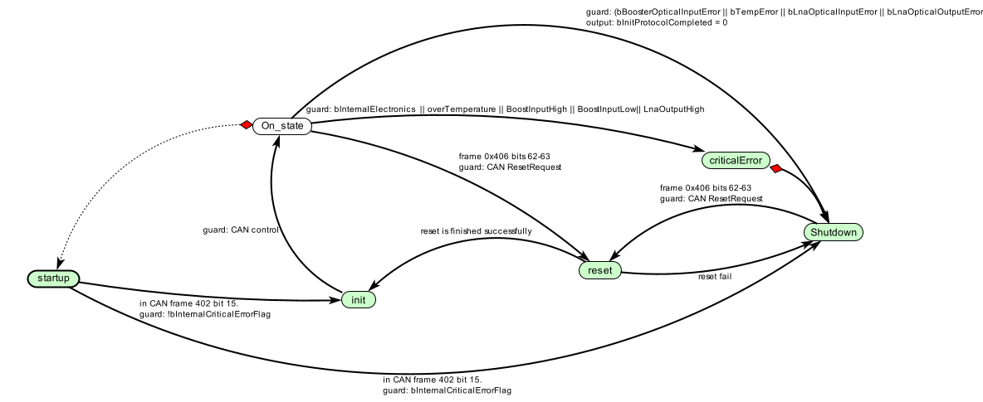

Figure 2 HPA output power ADC channels

### Common Section Functional Requirements

#### Startup Protocol

##### 2.2.4.1.1 Functional Description

In this state, the system is preparing the full and clean initialization of the OA. The lasers are disable and the power control lines for the laser are shutdown. In this state, the external calibration factors are not read from the external NVM yet. If a critical alarm is detected, the system will keep stuck in this state until a power cycle be done.

##### 2.2.4.1.2 Requirements Description

2.2.4.1.1 The system should initialize the Booster state machine

2.2.4.1.2 The system should initialize the LNA state machine

2.2.4.1.3 The system should disable the power for the lasers

2.2.4.1.4 The system should disable the enable lines for the Booster Sm laser

2.2.4.1.5 The system should disable the enable lines for the LNA Sm laser

2.2.4.1.6 The system should disable the enable lines for the Booster Mm1 and Mm2 lasers

2.2.4.1.7 After the shutdown of the drivers, the system should wait 100 miliseconds, in order to stabilize the temperature sensors.

2.2.4.1.8 If after the 100 ms, the temperature critical alarms are off, the system should set the flag “ResetFromStartupFlag” and transition to INIT state.

2.2.4.1.9 If after the 100 ms, the temperature critical alarms are on, the system should stay stuck in this state until power off.

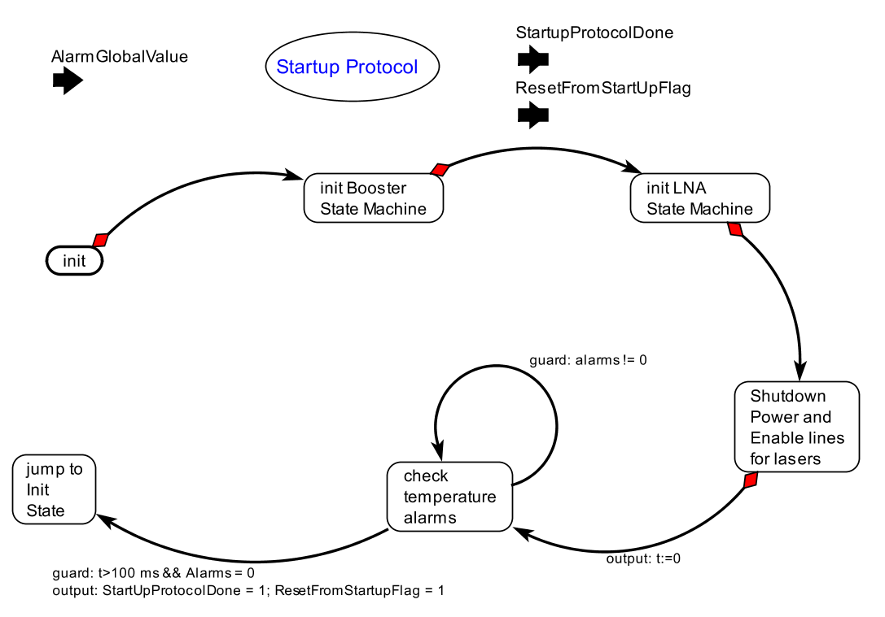

Figure 3 Startup Protocol of the Common section

#### Initialize Protocol

##### 2.2.4.2.1 Functional Description

In the OA we can distinguish three memories where the calibration factors can be storage: the NVM image, the operational RAM memory and the RAM copy image. In normal the operation of the OA shall be based on the calibration coefficients present in the operational RAM memory.

The OA should be able to do a partial Reset or initialization in orbit. This is, the OA should be able to initialize the Booster or initialize the LNA. When one of the components is initialized, the other should keep working normally. The objective is to not lose an established satellite to satellite link and avoid having to go through a complete PAT (pointing acquisition and tracking procedure) again.

This has the consequence that the copying of the NVM memory into the operational RAM memory should be segmented in a portion that belong to the Booster, to the LNA and to the general coefficients related to the general OA operation, we name this section the Common section.

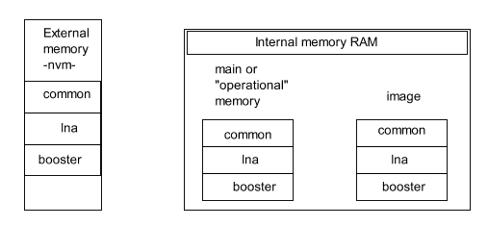

Figure 4 Memory sections in the OA

The OA accept three types of RESET commands: reset LNA, reset Booster or RESET all. These messages will come from the master through the CAN bus communication or in the case the system comes from the Startup State, a RESET all is performed.

When the system receives a command to Reset one the memories, number 2 in the **Figure 5 Logic behavior for the memory update**, the OA will read the specific section on the NVM memory. Then, it will copy the memory in the two internal RAM memories: the operational and in the Ram image.

This operation could be done only if the hardware under consideration (LNA or Booster or both) has been disabled and no critical alarms exists.

Calibration Process

The calibration process could be divided in the following steps:

1. The calibration starts when the OA receives the CAN bus commands to updated a calibration factor, number 1 in the **Figure 5 Logic behavior for the memory update**. These values will be saved in the “image RAM memory”. The system can be running normally while receiving the new calibration factors.
2. The OA receives the CAN bus command to save the new information into the NVM memory, number 3 in the **Figure 5 Logic behavior for the memory update**. The system can be running normally at that moment.
3. The OA receives the CAN bus command to RESET, number 2 in the **Figure 5 Logic behavior for the memory update**. Depending on the RESET type, the OA will shutdown the hardware section associated and then, the memory region of the NVM will be copied into the “operational RAM memory” and the “RAM image” memory.

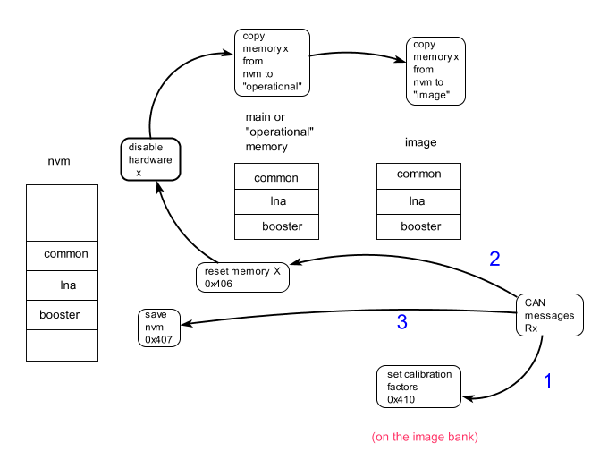

Figure 5 Logic behavior for the memory update

##### 2.2.4.2.2 Requirements Description

2.2.4.2.2.1 The system should initialize the Booster state machine

|  |  |
| --- | --- |
|  |  |
|  |  |

### Booster Functional Requirements

#### The Booster

2.2.2.1.2 Each input channel on the booster section shall be allocated a specific ITU channel wavelength and be selectable for optical readout by CAN bus control. Each one of these inputs should be calibrated individually. (CM3-REQ-EDFA-203-2)

#### Booster Output power monitor

The MCU shall monitor the optical output for the HPA. Two ADC channels are allocated for the power output: channel LOW and channel HIGH. Each one of them are used to read the output power using the following logic (**Figure 1 HPA output power channels**)**.**

2.2.1.3.1 Being in the minimum power output, if that signal increase, the LOW channel is used to report the optical output power (state number 1 of the figure 1), until the “LOW threshold” is achieved.

2.2.1.3.2 The threshold for the LOW could be calibrated and is given in raw counts and this should be done for each wavelength.

2.2.1.3.3 if the output power goes up from the “LOW threshold”, then the HIGH channel is used to report the optical output power (state number 2 of the figure 1).

2.2.1.3.4 If being in the state number 2, the output power goes down from the “LOW threshold”, but above to the “HIGH threshold”, the system will keep use the HIGH channel. (state number 3 of the figure 1).

2.2.1.3.5 The threshold for the HIGH could be calibrated and is given in raw counts and this should be done for each wavelength.

2.2.1.3.6 If being in the state number 3, the output power goes down from the “HIGH threshold”, the system will use the LOW channel. (state number 4 of the figure 1).

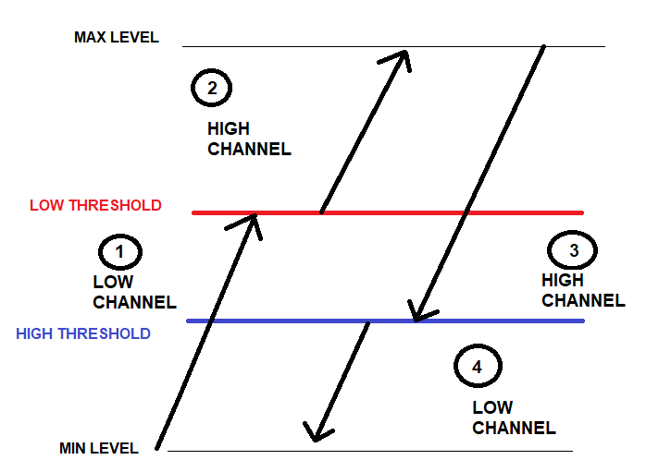

Figure 1 HPA output power ADC channels

#### Booster Input power monitor and LOS

2.2.1.4.1 The input power monitor use one ADC channel. This channel should be calibrated, and this should be done for each wavelength.

2.2.1.4.2 A loss of signal (LOS) situation should be avoided. A LOS detection will generate an alarm and makes the system reacts in consequence.

2.2.1.4.3 To configure a LOS, two values are used: LOS SET threshold and LOS CLEAR. Each one of them could be calibrated and this should be done for each wavelength.

2.2.1.4.4 The LOS CLEAR value must be greater than the LOS SET threshold.

2.2.1.4.5 The LOS detection is illustrated in the **Figure 2 LOS detection.** When the input signal is lower than the LOS threshold, the amplifier must turn off.

2.2.1.4.6 When the input power increases over the LOS clear value, the amplifier must resume the operation.



Figure 2 LOS detection

#### booster Input Backfacet monitor

2.2.1.5.1 The system should allow to calibrate single mode laser diode back-facet power monitor.

2.2.1.5.2 The system should allow to calibrate a threshold power for the single mode laser diode that allows to operate the multimode laser diodes. This threshold is given in percentage of the maximum current drive by the SM pump.

#### Booster Input current monitor

2.2.4.5.1 The HPA should have current monitors for the SM, MM1 and MM2 pumps. Each one of them should be calibrated individually.

2.2.4.5.1 The MCU shall use internal ADC channel to monitor the actual current passing through the single-mode laser diode (SM). This current is proportional to the voltage measured across a sense resistor network.

* + - * 1. The monitored current value (raw value) shall be available to the Host upon request.
        2. The MCU shall use the prescribed transfer function to convert the raw measured value into an engineering value (mA).
        3. A maximum operating current for the single modes (SM) laser diode(s) driver should be calibrated.

2.2.4.5.1 The MCU shall use internal ADC channel to monitor the actual current passing through the single-mode laser diode (MM1). This current is proportional to the voltage measured across a sense resistor network.

* + - * 1. The monitored current value (raw value) for MM1 shall be available to the Host upon request.
        2. The MCU shall use the prescribed transfer function to convert the raw measured value into an engineering value (mA).
        3. A maximum operating current for the single modes (MM1) laser diode(s) driver should be calibrated.

2.2.4.5.1 The MCU shall use internal ADC channel to monitor the actual current passing through the single-mode laser diode (MM2). This current is proportional to the voltage measured across a sense resistor network.

* + - * 1. The monitored current value (raw value) shall be available to the Host upon request.
        2. The MCU shall use the prescribed transfer function to convert the raw measured value into an engineering value (mA).
        3. A maximum operating current for the single modes (MM2) laser diode(s) driver should be calibrated.

#### Booster Output current power monitor

#### Booster Critical Alarms

Some alarms are a sign of a critical situation where the safety of the optical or electrical system could be compromised. If this happens, the system should react, stops all the Booster amplification operations and stays in a particular non-operational state where the alarms should be reported. The user can then, reset the Booster, clear the alarms in order to re-try the normal operations and see if the anomaly has disappeared.

2.2.3.7.1 When one or more of the critical alarms has been triggered, the system should stop the operation and report the alarm.

2.2.3.7.2 If the temperature on the single mode pump laser is above his maximum accepted level, a critical alarm is triggered and reported.

2.2.3.7.3 If the temperature on the single mode pump laser is under his minimum accepted level, a critical alarm is triggered and reported.

2.2.3.7.4 If a stuck condition is reported in the single mode laser diode, a critical alarm is triggered and reported.

2.2.3.7.5 If a stuck condition is reported in both multi-mode laser diodes, a critical alarm is triggered and reported.

2.2.3.7.6 If a stuck condition is reported in only one of the multi-mode laser diodes, don’t trigger the critical alarm, but should be reported.

2.2.3.7.7 If a LOS (Lost of Signal) in the optical input is detected, a critical alarm is triggered and reported.

2.2.3.7.8 If a LOS (Lost of Signal) in the optical input is detected, a critical alarm is triggered and reported.

#### HPA State machine

The behaviour for the HPA is illustrated in the **Figure 4 HPA FSM** and the **Table 1 HPA transition table** .

|  |  |  |  |  |
| --- | --- | --- | --- | --- |
| ALARM BOOSTER | Execute BoosterAlarmProtocol | From: “ANYSTATE” | Automatic | Triggered by BoosterAlarmDetected |
|  |  | To: “DISABLE Booster” | Automatic | **BoosterAlarmProtocol** completed |
| DISABLE BOOSTER | Execute DisableBoosterProtocol | To: Standby Booster | Automatic | **DisableBoosterProtocol** completed |
|  |  |  |
| STANDBY  BOOSTER | Execute **StandbyBoosterProtocol** | From: “DISABLE Booster” | Automatic | **DisableBoosterProtocol** completed |
| To: “ACC Booster” | Automatic | **StandbyBoosterProtocol** completed |
| To: “APC Booster” | Manual | Command on the CAN bus (Cfr. **SETMode** function) |
|  |  | To: “DISABLE Booster” | Manual | Command on the CAN bus (Cfr. RESET booster or RESET ALL function) |
|  |  |  |  |  |
|  |  |  |  |  |
| ACC BOOSTER | Execute **ACCBoosterProtocol** | From : “STANDBY Booster” | Automatic | **StandbyBoosterProtocol** completed |
| To: “DISABLE Booster” | Manual | Command on the CAN bus (Cfr. **SETMode** function) |
| APC  BOOSTER | Execute **APCBoosterProtocol** | From: “STANDBY Booster” | Manual | Command on the CAN bus (Cfr. **SETMode** function) |
| To : “DISABLE Booster” | Manual | Command on the CAN bus (Cfr. **SETMode** function) |

Table 1 HPA transition table

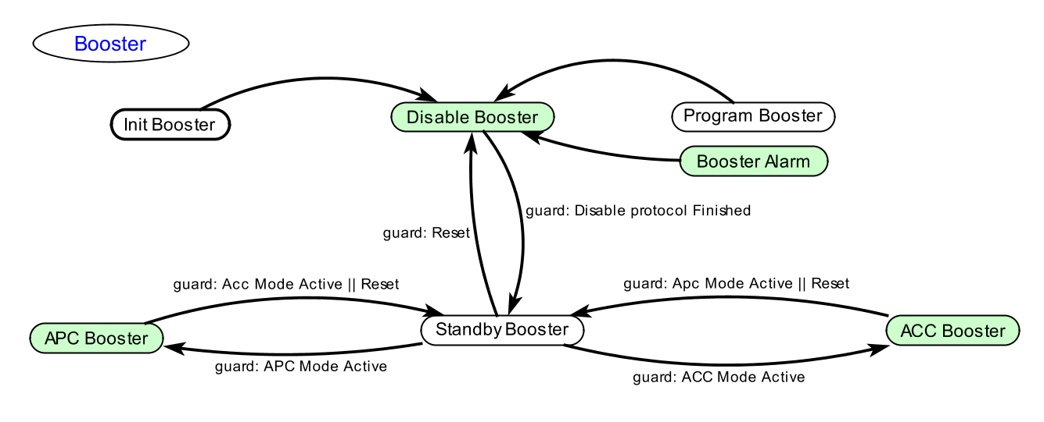

Figure 4 HPA FSM

2.2.5.8.1 The system should start in “Disable” state. The system should start in “Disable” state. In that state, the system should follow the “Disable sequence” protocol indicated in section 2.2.5.9.

2.2.5.8.2 When the “Disable sequence” protocol is finished, the system transition to the state “Standby Booster”.

2.2.5.8.3 Being in state Standby, if the RESET message is received from the CAN, the system goes back to “Disable Booster”

#### APC HPA conditions to turn OFF

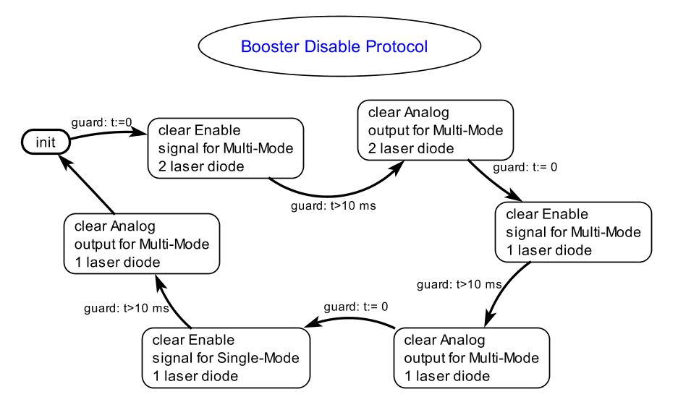

To power OFF the HPA, the following sequence must be applied:

2.2.1.15.1 Disable the HPA by switch the MM pumps off (HPA_MM_LDD_ENA1: LOW and HPA_MM_LDD_ENA2:LOW).

2.2.1.15.2 Reset the MM pumps current to 0-mA (or minimum current setting).

2.2.1.15.3 Switch the single mode pump off (HPA_LDD_nENA: HIGH) and reset the single mode pump current (HPA_PWM_STP1) to 0-mA (or minimum current setting).

#### ACC HPA

To power ON the HPA, the following sequence must be applied:

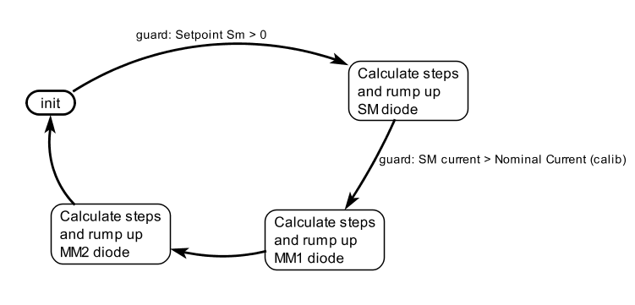

|  |  |  |  |  |
| --- | --- | --- | --- | --- |
|  |  |  |  |  |
| ACC BOOSTER | Execute **ACCBoosterProtocol** | From : “STANDBY Booster” | Automatic | **StandbyBoosterProtocol** completed |
| To: “DISABLE Booster” | Manual | Command on the CAN bus (Cfr. **SETMode** function) |
| APC  BOOSTER | Execute **APCBoosterProtocol** | From: “STANDBY Booster” | Manual | Command on the CAN bus (Cfr. **SETMode** function) |
| To : “DISABLE Booster” | Manual | Command on the CAN bus (Cfr. **SETMode** function) |

2.2.5.10.1 if being in ACC mode, the system changes the operation mode to APC, the system close the control signals and the system transition to “Disable booster”

2.2.1.11.3

2.2.1.11.4 Configure the HPA to operate in APC mode: set the output power set-point, select the correct wavelength

Enable HPA to operate in APC mode. – execute 2.2.1.12 APC HPA.

2.2.1.11.5 If the device is in LOS mode, the LD drivers should not work.

1. If the device is not in LOS mode the single mode LD driver current should increase the nominal operating value.
2. 2.2.1.11.6. If the device is not in LOS mode but the single-mode laser diode back-facet power is less than a threshold power, none of the multi-mode LD drivers should work.
3. 2.2.1.11.7 If the device is not in LOS mode and the back-facet power of the single mode laser diode is higher than the threshold power, the current of the two multimode LD drivers should increase together until the target output power is reached.

#### APC HPA

2.2.1.12.1 With the enable signals for the SM and MM pumps, the APC setpoint can be set using the **SETBoosterPowerAPC** function. if the setpoint is in 0, the HPA should generate an output signal of 16 dBm.

2.2.1.12.2 The set value of the individual booster laser driver currents is ignored and not used in booster APC mode.

2.2.1.12.3 While in APC mode, the booster may be enabled and disabled any number of times with the **ENABLE/DISABLEBooster** function

2.2.1.12.4 In order to trigger the MM pumps, the SM should be running at least at a minimum percentage of the maximum current. This percentage is settable via factory calibration.

2.2.1.12.5 When the power setpoint start to increase, the PID control loop is executed on the first MM pump. This loop will be running until the current of the MM pump reaches a predefined current value (factory calibrated to 1500 mA).

2.2.1.12.6 When the first pump reaches the max. current value for the first stage, it stays at that value and a second PID loop on the second MM pump is triggered.

2.2.1.12.7 When the second pump reaches the max. current value for the second stage, it stays at that value and a third PID loop on both MM pumps is triggered.

2.2.1.12.8 Being in the MM1 and MM2 running parallel stage, and the power setpoint decrease, if the current reaches the 1500 mA, the third PID loop stops. The MM1 pump stays at 1500mA and the MM2 executes the control Pid loop.

2.2.1.12.9 Being in the MM2 PID control loop and the power setpoint keep decreasing, the MM2 current also decrease until it reaches its minimum value. In that point, the second stage PID loop stops and the stage PID loop starts.

2.2.1.12.10 If the MM1 laser driver is enabled and the MM2 is disabled, with the **ENABLE/DISABLEBooster** function, then internally in the OA the necessary currents are supplied to the MM1 laser drivers to MAINTAIN the set booster APC optical output power.

2.2.1.12.11 If the MM2 laser driver is enabled and the MM1 is disabled, with the **ENABLE/DISABLEBooster** function, then internally in the OA the necessary currents are supplied to the MM2 laser drivers to MAINTAIN the set booster APC optical output power.

|  |  |  |  |  |
| --- | --- | --- | --- | --- |
| ALARM BOOSTER | Execute BoosterAlarmProtocol | From: “ANYSTATE” | Automatic | Triggered by BoosterAlarmDetected |
| To: “DISABLE Booster” | Automatic | **BoosterAlarmProtocol** completed |
| STANDBY  BOOSTER | Execute **StandbyBoosterProtocol** | From: “DISABLE Booster” | Automatic | **DisableBoosterProtocol** completed |
| To: “ACC Booster” | Automatic | **StandbyBoosterProtocol** completed |
| To: “APC Booster” | Manual | Command on the CAN bus (Cfr. **SETMode** function) |
| ACC BOOSTER | Execute **ACCBoosterProtocol** | From : “STANDBY Booster” | Automatic | **StandbyBoosterProtocol** completed |
| To: “DISABLE Booster” | Manual | Command on the CAN bus (Cfr. **SETMode** function) |

#### APC HPA shutdown because critical alarms

A critical alarm on the booster will cause the system turn OFF all the drivers. The following alarms will trigger the critical alarm:

* Any temperature goes over the physical hard high and low temperature limits.
* The booster optical input went over the physical hard high limit.
* The booster optical output went over the physical hard high limit.
* Any booster laser driver was detected permanently stuck to enabled.
* “Backfacet” current on SM1 under the minimum threshold level.
* The booster optical input falls into a Loss of signal (LOS) situation.

2.2.1.18.1 When an alarm is triggered, it should be reported through the CAN bus.

2.2.1.18.2 Being in the MM1 and MM2 running parallel stage, and the “**backfacet**” current monitor alarm is triggered, the shutdown sequence should run following the sequence: “MM1 and MM2” control loop shutdown, MM2 control loop shutdown, MM1 control loop shutdown and Single mode shutdown. The shutdown includes the hardware disable of the driver. Once the back-facet power is again higher than the threshold power, resume the operation

2.2.1.18.3 Being in the MM1 and MM2 running parallel stage, and any of the drivers are stuck, the “**driver stuck**” alarm is triggered, the shutdown sequence should run following the sequence: “MM1 and MM2” control loop shutdown, MM2 control loop shutdown, MM1 control loop shutdown and Single mode shutdown. The shutdown includes the hardware disable of the driver.

2.2.1.18.4 Being in the MM1 and MM2 running parallel stage, and the **bBoosterOutputPowerIsTooHigh** alarm is triggered, the shutdown sequence should run following the sequence: “MM1 and MM2” control loop shutdown, MM2 control loop shutdown, MM1 control loop shutdown and Single mode shutdown. The shutdown includes the hardware disable of the driver.

2.2.1.18.5 Being in the MM1 and MM2 running parallel stage, and the **bBoosterInputPowerIsTooHigh** alarm is triggered, the shutdown sequence should run following the sequence: “MM1 and MM2” control loop shutdown, MM2 control loop shutdown, MM1 control loop shutdown and Single mode shutdown. The shutdown includes the hardware disable of the driver.

2.2.1.18.6 Being in the MM1 and MM2 running parallel stage, and the **bBoosterInputPowerLOSAlarm** alarm is triggered, the shutdown sequence should run following the sequence: “MM1 and MM2” control loop shutdown, MM2 control loop shutdown, MM1 control loop shutdown and Single mode shutdown. The shutdown includes the hardware disable of the driver.

If at any time the input signal is lost, both MMLD drivers should turn OFF (or reset each driver current), and then SM LD driver should turn OFF (or reset the driver current). Once the LOS is cleared, resume the operation.

2.2.1.18.7 Being in the MM1 and MM2 running parallel stage, and the **bHpaMm1AlarmTooHighTemperature** alarm is triggered, the shutdown sequence should run following the sequence: “MM1 and MM2” control loop shutdown, MM2 control loop shutdown, MM1 control loop shutdown and Single mode shutdown. The shutdown includes the hardware disable of the driver.

2.2.1.18.8 Being in the MM1 and MM2 running parallel stage, and the **bHpaMm2AlarmTooHighTemperature** alarm is triggered, the shutdown sequence should run following the sequence: MM1 and MM2 control loop shutdown, MM2 control loop shutdown, MM1 control loop shutdown and Single mode shutdown. The shutdown includes the hardware disable of the driver.

2.2.1.18.9 Being in the MM1 and MM2 running parallel stage, and the **bHpaSmAlarmTooHighTemperature** alarm is triggered, the shutdown sequence should run following the sequence: MM1 and MM2 control loop shutdown, MM2 control loop shutdown, MM1 control loop shutdown and Single mode shutdown. The shutdown includes the hardware disable of the driver.

|  |  |  |  |  |
| --- | --- | --- | --- | --- |
| ALARM BOOSTER | Execute BoosterAlarmProtocol | From: “ANYSTATE” | Automatic | Triggered by BoosterAlarmDetected |
| To: “DISABLE Booster” | Automatic | **BoosterAlarmProtocol** completed |
| STANDBY  BOOSTER | Execute **StandbyBoosterProtocol** | From: “DISABLE Booster” | Automatic | **DisableBoosterProtocol** completed |
| To: “ACC Booster” | Automatic | **StandbyBoosterProtocol** completed |
| To: “APC Booster” | Manual | Command on the CAN bus (Cfr. **SETMode** function) |
| ACC BOOSTER | Execute **ACCBoosterProtocol** | From : “STANDBY Booster” | Automatic | **StandbyBoosterProtocol** completed |
| To: “DISABLE Booster” | Manual | Command on the CAN bus (Cfr. **SETMode** function) |
| APC  BOOSTER | Execute **APCBoosterProtocol** | From: “STANDBY Booster” | Manual | Command on the CAN bus (Cfr. **SETMode** function) |
| To : “DISABLE Booster” | Manual | Command on the CAN bus (Cfr. **SETMode** function) |

Table 2 HPA APC transition table

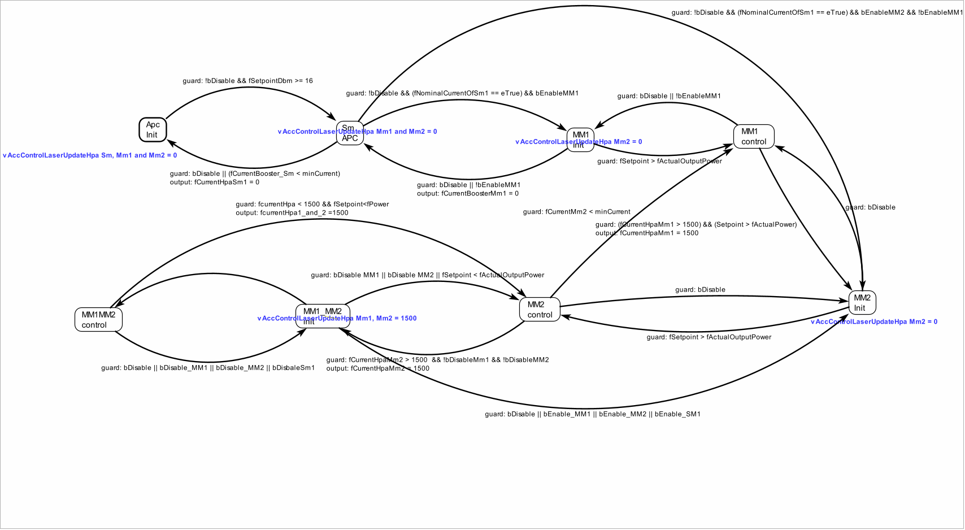

#### APC HPA non critical alarms

* Booster current
* 2.2.1.18.3 Being in the MM1 and MM2 running parallel stage, and the bBoosterCurrentIsTooHigh alarm is triggered, the shutdown sequence should run following the sequence: MM1 and MM2 control loop shutdown, MM2 control loop shutdown, MM1 control loop shutdown and Single mode shutdown. The shutdown includes the hardware disable of the driver.

Figure 2 HPA input stuck detection

### LNA Functional

#### LNA Input Power monitor

2.2.1.4.1 The unit control section shall monitor individually both input channels of booster section. (CM3-REQ-EDFA-205-1N )

2.2.1.3.1 The unit shall contain a LNA section that wavelength routes an amplified input signal to one of two dedicated optical output channels. The input wavelength will either correspond to ITU channel 30 or ITU channel 51. (CM3-REQ-EDFA-204-1)

#### LNA output Power monitor

2.2.1.5.1. The unit control section shall monitor the optical output of the booster section.( CM3-REQ-EDFA-206-1N)

2.2.1.5.2 The unit control section shall monitor the optical outputs individually of the LNA section. (CM3-REQ-EDFA-207-1N)

#### LNA current monitor

**2.2.1.6.1.**

#### ACC LNA

#### APC LNA

### Temperature Functions

The unit has three thresholds or limit values for the temperatures:

* Pump Temperature High Alarm Limit
* Pump Temperature Very Low Alarm Limit
* Pump Temperature Very High Alarm Limit

The Very Low and Very high limits should generate a critical error.

The high alarm limit will be reported but will not generate a critical error.

2.2.1.14.1 The unit shall monitor and report the temperature of the LNA single mode pump.

2.2.1.14.2 The unit shall monitor and report the temperature of the HPA single mode pump.

2.2.1.14.3 The unit shall monitor and report the temperature of the HPA multi mode 1 pump.

2.2.1.14.4 The unit shall monitor and report the temperature of the HPA multi mode 2 pump.

2.2.1.14.5 The unit shall monitor and report the temperature of the HPA multi mode 3 pump.

2.2.1.14.6 The unit shall monitor and report the temperature of the HPA multi mode 4 pump.

2.2.1.14.7 In ACC, if the LNA single mode temperature overpass the limit stablished for the “Very high alarm limit”, a critical error flag should be triggered and reported through the 0x402 frame. The LNA and the HPA should be disabled, following the procedure stablished in the section ***2.2.1.2 . sequence for shutdown LNA***

2.2.1.14.8 In APC, if the LNA single mode temperature overpass the limit stablished for the “Very high alarm limit”, a critical error flag should be triggered and reported through the 0x402 frame. The LNA and the HPA should be disabled. ***2.2.1.2 . sequence for shutdown LNA***

2.2.1.14.9 In ACC, if the LNA single mode temperature overpass the limit stablished for the “High alarm limit”, a critical error flag will **not** be triggered. The alarm will be reported through the 0x428 frame.

2.2.1.14.10 In APC, if the LNA single mode temperature overpass the limit stablished for the “High alarm limit”, a critical error flag will **not** be triggered. The alarm will be reported through the 0x428 frame.

2.2.1.14.11 In ACC, if the HPA multimode pump 1 temperature overpass the limit stablished for the “Very high alarm limit”, a critical error flag should be triggered and reported through the 0x402 frame. The LNA and the HPA should be disabled, following the requirements stablished in the section: 2.2.1.12. **Sequence for shutdown HPA**.

2.2.1.14.12 In APC, if the HPA multimode pump 1 temperature overpass the limit stablished for the “Very high alarm limit”, a critical error flag should be triggered and reported through the 0x402 frame. The LNA and the HPA should be disabled, following the requirements stablished in the section: 2.2.1.12. **Sequence for shutdown HPA**.

2.2.1.14.13 In ACC, if the HPA multimode pump 1 temperature overpass the limit stablished for the “High alarm limit”, a critical error flag will **not** be triggered. The alarm will be reported through the 0x428 frame.

2.2.1.14.14 In APC, if the HPA multimode pump 1 temperature overpass the limit stablished for the “High alarm limit”, a critical error flag will **not** be triggered. The alarm will be reported through the 0x428 frame.

2.2.1.14.15 In ACC, if the HPA multimode pump 2 temperature overpass the limit stablished for the “Very high alarm limit”, a critical error flag should be triggered and reported through the 0x402 frame. The LNA and the HPA should be disabled, following the requirements stablished in the section: 2.2.1.12. **Sequence for shutdown HPA**.

2.2.1.14.16 In APC, if the HPA multimode pump 2 temperature overpass the limit stablished for the “Very high alarm limit”, a critical error flag should be triggered and reported through the 0x402 frame. The LNA and the HPA should be disabled, following the requirements stablished in the section: 2.2.1.12. **Sequence for shutdown HPA**.

2.2.1.14.17 In ACC, if the HPA multimode pump 2 temperature overpass the limit stablished for the “High alarm limit”, a critical error flag will **not** be triggered. The alarm will be reported through the 0x428 frame.

2.2.1.14.18 In APC, if the HPA multimode pump 2 temperature overpass the limit stablished for the “High alarm limit”, a critical error flag will **not** be triggered. The alarm will be reported through the 0x428 frame.

2.2.1.14.16 In ACC, if the HPA multimode pump 3 temperature overpass the limit stablished for the “Very high alarm limit”, a critical error flag should be triggered and reported through the 0x402 frame. The LNA and the HPA should be disabled, following the requirements stablished in the section: 2.2.1.12. **Sequence for shutdown HPA**.

2.2.1.14.17 In APC, if the HPA multimode pump 3 temperature overpass the limit stablished for the “Very high alarm limit”, a critical error flag should be triggered and reported through the 0x402 frame. The LNA and the HPA should be disabled, following the requirements stablished in the section: 2.2.1.12. **Sequence for shutdown HPA**.

2.2.1.14.18 In ACC, if the HPA multimode pump 3 temperature overpass the limit stablished for the “High alarm limit”, a critical error flag will **not** be triggered. The alarm will be reported through the 0x428 frame.

2.2.1.14.19 In APC, if the HPA multimode pump 3 temperature overpass the limit stablished for the “High alarm limit”, a critical error flag will **not** be triggered. The alarm will be reported through the 0x428 frame.

2.2.1.14.21 In ACC, if the HPA multimode pump 2 temperature overpass the limit stablished for the “Very high alarm limit”, a critical error flag should be triggered and reported through the 0x402 frame. The LNA and the HPA should be disabled, following the requirements stablished in the section: 2.2.1.12. **Sequence for shutdown HPA**.

2.2.1.14.22 In APC, if the HPA multimode pump 2 temperature overpass the limit stablished for the “Very high alarm limit”, a critical error flag should be triggered and reported through the 0x402 frame. The LNA and the HPA should be disabled, following the requirements stablished in the section: 2.2.1.12. **Sequence for shutdown HPA**.

2.2.1.14.23 In ACC, if the HPA multimode pump 2 temperature overpass the limit stablished for the “High alarm limit”, a critical error flag will **not** be triggered. The alarm will be reported through the 0x428 frame.

2.2.1.14.24 In APC, if the HPA multimode pump 2 temperature overpass the limit stablished for the “High alarm limit”, a critical error flag will **not** be triggered. The alarm will be reported through the 0x428 frame.

2.2.1.14.25. The thresholds or limit values for the “high alarm limit” temperature, should have a default value of 70 degrees Celsius.

2.2.1.14.26. The thresholds or limit values for the “high alarm limit” temperature, could be calibrated by CAN bus.

2.2.1.14.27. The thresholds or limit values for the “Very high alarm limit” temperature, should have a default value of 90 degrees Celsius.

2.2.1.14.28. The thresholds or limit values for the “Very high alarm limit” temperature, could be calibrated by CAN bus.

2.2.1.14.29. The thresholds or limit values for the “Very low alarm limit” temperature, should have a default value of 90 degrees Celsius.

2.2.1.14.30. The thresholds or limit values for the “Very low alarm limit” temperature, could be calibrated by CAN bus.

|  |  |
| --- | --- |
| alarm | Bit position |
| Lna Input Power Is Too Low | 0 |
| Lna Input Power Is Too High | 1 |
| Lna Output Power Is Too High | 2 |
| Lna Current High Alarm Status | 3 |
| Booster backfacet Is correct | 4 |
| Booster Input Power LOS Alarm | 5 |
| Booster Input Power Is Too High | 6 |
| Sm Driver Stucked | 7 |
| Mm1 Driver Stucked | 8 |
| Mm2 Driver Stucked | 9 |
| Booster Output Power Is Too High | 10 |
| Booster Current Is Too High | 11 |
| bRXCANHasAError | 12 |
| bMemoryACrcErrorDetectedAtPowerUp | 13 |
| bInternalAdcError28vVmCh1TooLow | 14 |
| bInternalAdcError7vPwrVmCh2tooLow | 15 |
| bInternalAdcError3vPwrVmTooLow | 16 |
| bInternalAdcErrorAdcPwrCmtooLow | 17 |
| bPassWordValidated | 18 |
| bLnaSmAlarmWayTooLowTemperature | 19 |
| bLnaSmAlarmTooHighTemperature | 20 |
| bLnaSmAlarmWayTooHighTemperature | 21 |
| bHpaSmAlarmWayTooLowTemperature | 22 |
| bHpaSmAlarmTooHighTemperature | 23 |
| bHpaSmAlarmWayTooHighTemperature | 24 |
| bHpaMm1AlarmWayTooLowTemperature | 25 |
| bHpaMm1AlarmTooHighTemperature | 26 |
| bHpaMm1AlarmWayTooHighTemperature | 27 |
| bHpaMm2AlarmWayTooLowTemperature | 28 |
| bHpaMm2AlarmTooHighTemperature | 29 |
| bHpaMm2AlarmWayTooHighTemperature | 30 |
| bResetFromStartupState | 31 |

#### APC HPA critical alarms

|  |  |  |  |  |  |  |
| --- | --- | --- | --- | --- | --- | --- |
| Index | Parameter Monitored | Expected Range | Alarm | | Fault | |
| 0 | OA temperature | -40 to 90 oC | Low | High | - | High |
|  |  |  |  |  |  |  |
|  |  |  |  |  |  |  |
|  |  |  |  |  |  |  |
|  |  |  |  |  |  |  |
|  |  |  |  |  |  |  |
|  |  |  |  |  |  |  |

#### CAN commands

2.2.1.7.1 The unit shall have a RESET command to bring all internal control variables back to default values.( CM3-REQ-EDFA-210-1N)

2.2.1.7.2 The unit shall have an ENABLE/DISABLE command for each internal pump laser in the booster section and LNA section. (CM3-REQ-EDFA-211-1N)

2.2.1.7.3 The unit shall have a selection command for the booster input channel that will be amplified. (CM3-REQ-EDFA-212-1N)

2.2.1.7.4. The unit shall have a selection command for the LNA section output channel. (CM3-REQ-EDFA-213-1N)

2.2.1.7.5 The unit shall have a command to set the pump laser current for each of the amplification stages individually in the booster section and LNA section. (CM3-REQ-EDFA-214-1N)

2.2.1.7.6 The unit shall have a command to select the operational mode of the booster section (ACC or APC). 9 CM3-REQ-EDFA-215-1N)

2.2.1.7.7 The unit shall have a command to select the operational mode of the LNA section (ACC or APC). (CM3-REQ-EDFA-216-1N)

2.2.1.7.8 The unit shall have a command to set the low limit and high limit of : (CM3-REQ-EDFA-217-1N)  
1) (withdrawn)  
2) the LNA section optical output power  
3) the Booster section optical input power  
4) the Booster section optical output power  
5) the LNA laser pump current  
6) the LNA back facet laser current  
7) the Booster laser pump 1 current  
8) the internal mounting base temperature

2.2.1.7.9 The unit shall have a command to store all actual settings of internal operational parameters into non-volatile memory. (CM3-REQ-EDFA-218-1N)

2.2.1.7.10 The unit shall report the booster section input optical power on the selected input channel. (CM3-REQ-EDFA-219-1N)

2.2.1.7.11 The unit shall report the LNA section output optical power on the selected output channel. (CM3-REQ-EDFA-220-1N)

2.2.1.7.12 The unit shall report the booster section output optical power. (CM3-REQ-EDFA-221-1N)

2.2.1.7.13 the unit shall report the current of each laser pump in either the booster section or LNA section. (CM3-REQ-EDFA-222-1N)

2.2.1.7.14 The unit shall report the enable/disable status of each laser pump in the booster section and LNA section. (CM3-REQ-EDFA-223-1N)

2.2.1.7.15 The unit shall report the operational mode (ACC/APC) of both Boost section and LNA section. (CM3-REQ-EDFA-224-1N)

2.2.1.7.16 The unit shall report the channel selection of both the booster section and LNA section. (CM3-REQ-EDFA-225-1N)

2.2.1.7.17 The unit shall report an alarm status for each laser pump current in the LNA section that goes out of limits. (CM3-REQ-EDFA-226-1N)

2.2.1.7.18 The unit shall report an alarm status for each laser pump current in the booster section that goes out of limits. (CM3-REQ-EDFA-227-1N)

2.2.1.7.19 The unit shall report an alarm status if the booster section optical output power goes out of limits. (CM3-REQ-EDFA-228-1N)

2.2.1.7.20 The unit shall report an alarm status if the Booster section optical input power goes out of limits (for the selected wavelength channel). (CM3-REQ-EDFA-229-1N)

2.2.1.7.21 The unit shall report an alarm status if the LNA section optical output power goes out of limits (for each channel). (CM3-REQ-EDFA-230-1N)

2.2.1.7.22 The unit shall report the unit thermal interface surface temperature. (CM3-REQ-EDFA-231-1N)

2.2.1.7.23 The unit shall report an alarm status if the thermal interface surface temperature goes out of limits. (CM3-REQ-EDFA-232-1N)

2.2.1.7.24 The unit shall report an alarm status if a system safety shutdown has occurred. (CM3-REQ-EDFA-233-1N)

2.2.1.7.25 The unit shall monitor and report the power supply voltage. (CM3-REQ-EDFA-234-1N)

# Software Requirements

## Memory Management Requirements

The following group of requirements targets the handling of the application program and of the non-volatile parameters for the device.

3.1.1. The MCU shall automatically boot-up upon power up.

3.1.2. The code shall be divided into a boot section and an application section.

3.1.3 The boot section of the code shall be write protected.

## HPA Single Mode Laser Diode Controller

### Single-mode LD Monitor

3.2.1.1.

The MCU shall use an external ADC channel to monitor the internal temperature of the single-mode laser diode. This is done by reading the voltage across a reference network that includes the laser diode’s thermistor.

* + - 1. The monitored temperature value (raw value) shall be available to the Host upon request.
      2. The MCU shall use the prescribed transfer function to convert the raw measured value into an engineering value (oC).
      3. The MCU shall use an internal ADC channel to monitor the current passing through the single-mode laser diodes TEC. This is done by reading the voltage across a current sense resistor network.
      4. The monitored TEC current value (raw value) shall be available to the Host upon request.
      5. The MCU shall use the prescribed transfer function to convert the raw measured value into an engineering value (mA). The transfer function is described in AD99. Note that this value can be positive (cooling) or negative (heating).
      6. The MCU shall use an external ADC channel to monitor the output power of the 980 nm optical source. This is done by reading the voltage across a reference network that monitors the appropriate photo-diode current.
      7. When monitoring the 980 nm power, care must be taken to sample the analog value at the points of known maximum, in order to provide an accurate reading.
      8. The monitored photo-diode current value (raw value) shall be available to the Host upon request.
      9. The MCU shall use the prescribed transfer function to convert the raw measured value into an engineering value (mW).

### Single-mode LD Alarms

* + - 1. When the laser diode current exceeds 1000 mA, the excessive current alarm of the single-mode laser diode shall be set.
      2. It is not possible to clear the single-mode laser diode alarm bit after it has been set. The Host shall power cycle the Beacon to reset this bit.
      3. When the laser diode temperature is higher than +50 oC, the high temperature alarm of the single-mode laser diode shall be set.
      4. When the laser diode temperature is lower than -10 oC, the low temperature alarm of the single-mode laser diode shall be set.
      5. When the TEC current exceeds 255 mA in either direction, the excessive current alarm of the single-mode TEC shall be set.
      6. When the 980 nm output power exceeds 500 mW, the excessive 980 nm output power alarm shall be set.

### Single-mode LD Control

* + - 1. The MCU shall use one DAC channel to control the current to be injected into the single-mode laser diode. The optical power produced by the laser diode is proportional to the current through the laser diode.
      2. The laser-diode modulation frequency for the single-mode laser diode is from CW to 10 kHz.
      3. It shall not be assumed that the modulation frequency for the single-mode laser diode and for the multi-mode laser diode are the same.
      4. The minimum modulation format required shall be 33% duty-cycle square wave.
      5. When the Host changes the modulation frequency, the change shall be applied within 100 msec.
      6. The modulation frequency requested by the Host shall be kept in non-volatile memory and shall be retrieved when required.
      7. It shall be possible for the Host to change the peak 980 nm output power level during operation. The speed of change is to be determined.
      8. When the LDD disable line is activated by the Host, the current to be injected into the laser diode shall be of zero mA. This will in effect provide redundancy to the shutdown command.
      9. When the single-mode laser diode current exceeds 1000 mA, the laser diode drive current shall be set to zero and the modulation disabled. An alarm bit is also set.
      10. The laser diode driver (LDD) shall be turned off when the laser diode temperature is outside of the range from +5oC to +50 oC.
      11. The MCU shall have an open loop control to adjust the current injected into the single-mode laser diode as a function of the measured laser diode current. This is the ACCs loop.
      12. The ACCs control loop shall have an accuracy of 5 %. That is, the current into the laser diode shall be within 5 % of the current requested by the Host.
      13. The ACCs control loop shall have a frequency response of at least 50 Hz.
      14. When the Host changes the laser diode current value, the change shall be applied within 100 msec.
      15. The laser diode current requested by the Host shall be kept in non-volatile memory and shall be retrieved when required.
      16. The MCU shall have a P-I (proportional-Integral) control loop to adjust the current injected into the single-mode laser diode as a function of the power measured from the 980 nm output photo-diode. This is the APCs loop.
      17. The APCs control loop shall have an accuracy of 5 %.
      18. The APCs control loop shall have a frequency response of at least 50 Hz.
      19. When the Host changes the peak power value, the change shall be applied within 100 msec.
      20. The peak power level requested by the Host shall be kept in non-volatile memory and shall be retrieved when required.
      21. The ACCs and the APCs control modes shall be mutually exclusive. Only one can be active at any time.
      22. Setting a value of zero as the control point for the ACCs control shall result in the laser diode current being forced to zero. That is, the laser diode will be off.
      23. Setting a value of zero as the control point for the APCs control shall result in the laser diode current being forced to zero. That is, the laser diode will be off.
      24. When enabling the single-mode laser diode for the first time after power-up/reset, the laser diode driver shall remain OFF until the TEC control circuitry has been in operation.

## HPA Multi-Mode Laser Diode Controller

### Multi-mode LD Monitor

* + - 1. The MCU shall use an internal ADC channel to monitor the actual current passing through the multi-mode laser diode. This current is proportional to the voltage measured across a sense resistor network.
      2. The monitored current value (raw value) will be available to the Host upon request.
      3. The MCU shall use the prescribed transfer function to convert the raw measured value into an engineering value (mA).
      4. Since the laser diode current is likely to be modulated, care must be taken to sample the analog value at the points of known maximum, in order to provide an accurate reading.
      5. The MCU shall use an internal ADC channel to monitor the internal temperature of the multi-mode laser diode. This is done by reading the voltage across a reference network that includes the laser diode’s thermistor.
      6. The monitored temperature value (raw value) shall be available to the Host upon request.
      7. The MCU shall use the prescribed transfer function to convert the raw measured value into an engineering value (oC).
      8. The MCU shall use an internal ADC channel to monitor the output power of the 1545 nm optical source. This is done by reading the voltage across a reference network that monitors the appropriate photo-diode current. The 1545 nm output power is proportional to the current through the multi-mode laser diode.
      9. When monitoring the 1545 nm power, care shall be taken to sample the analog value at the points of known maximum, in order to provide an accurate reading.
      10. The monitored photo-diode current value (raw value) shall be available to the Host upon request.
      11. The MCU shall use the prescribed transfer function to convert the raw measured value into an engineering value (mW).

### Multi-mode LD Alarms

* + - 1. When the laser diode current exceeds 5000 mA, the excessive current alarm of the multi-mode laser diode shall be set.
      2. It is not possible to clear the single-mode laser diode alarm bit after it has been set.
      3. When the laser diode temperature is higher than +50oC, the high temperature alarm of the single-mode laser diode shall be set.

3.3.2.4 After the high temperature alarm of the single-mode laser diode has been set, it shall be cleared when the temperature decreases below +50 oC.

* + - 1. When the laser diode temperature is lower than -25oC, the low temperature alarm of the single-mode laser diode shall be set.

### Multi-mode LD Control

* + - 1. The MCU shall use one DAC channel to control the current to be injected into the multi-mode laser diode. The optical power produced by the laser diode is proportional to the current through the laser diode.
      2. The laser-diode modulation frequency for the multi-mode laser diode is from CW to 10 kHz at 50% modulation.
      3. It shall not be assumed that the modulation frequency for the multi-mode laser diode and for the single-mode laser diode are the same.
      4. The minimum modulation format required shall be 33% duty-cycle square wave.
      5. The square wave modulation shall be between the maximum value specified and the minimum value stored in memory. The minimum value is not zero.
      6. When the Host changes the modulation frequency, the change shall be applied within 100 msec.
      7. It shall be possible for the Host to change the peak 1545 nm output power level during operation. The speed of change is to be determined.
      8. It shall be possible during operation to adjust the “low” power level, which is also called the quasi-zero level. The reason is that a low enough level allows the laser diode to recover more rapidly, yet has no known effect on the receiver since the few photons produced will have been lost during transmission to the ground station.
      9. When the LDD disable line is activated by the Host, the current to be injected into the laser diode shall be of zero mA. This will in effect provide redundancy to the shutdown command.
      10. When the multi-mode laser diode current exceeds 5000 mA, the laser diode drive current shall be set to zero and the modulation disabled. An alarm bit is also set.
      11. The laser diode driver (LDD) shall be turned off when the laser diode temperature is outside of the range from ‑25oC to +55 oC.

3.3.3.13 The MCU shall have an open loop control to adjust the current injected into the single-mode laser diode as a function of the measured laser diode current. This is the ACCs loop.

* + - 1. The ACCs control loop shall have an accuracy of 5 %. That is, the current into the laser diode shall be within 5 % of the current requested by the Host.
      2. The ACCs control loop shall have a frequency response of at least 50 Hz.
      3. When the Host changes the laser diode current value, the change shall be applied within 100 msec.
      4. The MCU shall have a P-I (proportional-Integral) control loop to adjust the current injected into the single-mode laser diode as a function of the power measured from the 1545 nm output photo-diode. This is the APCs loop.
      5. The APCs control loop shall have an accuracy of 5 %.
      6. The APCs control loop shall have a frequency response of at least 50 Hz.
      7. When the Host changes the peak power value, the change shall be applied within 100 msec.
      8. The ACCs and the APCs control modes are mutually exclusive. Only one can be active at any time.
      9. Setting a value of zero as the control point for either the ACCs or the APCs controls shall result in the laser diode current being forced to zero. That is, the laser diode will be off.

## Normal Behaviour Expectations

The following requirements describes the expected normal behaviour of the Beacon.

* + 1. Upon power-up, the MCU will keep all laser diodes in the OFF state.
    2. Normally, only one MCU is active. It is nonetheless possible for the Host to request that both MCUs be active at the same time. This shall not cause interference from one MCU to the other one.
    3. Once the MCU has completed its boot-up sequence and has successfully loaded an application image, it will enable its heartbeat (wdg) line to the Host.
    4. The wdg line shall send a signal that is a 50% duty cycle square wave with a frequency of 10 kHz nominal (between 9 kHz and 11 kHz).
    5. The MCU will only activate a laser diode driver after receiving a valid command requesting this operation.
    6. Under normal operating conditions, only one of the two optical source in the MCU section will be activated by the Host at any given time. Nonetheless, the MCU must be capable of controlling both optical sources in its section simultaneously even this is expected to violate the power budget limits.
    7. The MCU will automatically disable a laser diode driver if it encounters a danger condition. The danger conditions are operating at an excessive temperature, operating at an excessive current, and operating at an excessive power.
    8. When the MCU disables a laser diode as a result of detecting a danger condition, it shall set the relevant bit in the Alarm/Event Register.
    9. The MCU will use an ADC channel to monitor the case temperature of the beacon. This is done by reading the voltage across a reference network that includes the thermistor fixed to the case.